Master Thesis – Research plan

Fears of a Utility Death Spiral: An Agent-based modelling case study of Zurich considering policy, electricity tariff structures and building functions – and consequent policy recommendations
Student: Prakhar Mehta, MEST (pmehta@student.ethz.ch)
Supervisors: Danielle Griego, PhD Candidate (+41 44 633 72 14, griego@arch.ethz.ch)]
Prof. Dr. Arno Schlueter (+41 (0)44 633 93 91, schlueter@arch.ethz.ch)
Starting date: 17.12.2018
End date: 10.06.2019
Work load: [1 ECTS = 25-30h, e.g. 30 ECTS = 750-900 h]

A Introduction
Since the events of Fukushima in 2011, Switzerland has voted to stop using nuclear power and switch to renewable energy instead, with the focus being on solar PV for the urban environment. As part of the Energy Strategy 2050, the new ‘Energy Act 730.0 (EnG)’ aims to reach to 11400 GWh of renewable energy production by the year 2035 [1]. Also, the old KEV feed-in tariff scheme has been discontinued and replaced with a one-time remuneration of up to 30% of the capital costs compared to a reference case installation for PV projects less than 30 kW after 2012 [1]. There is a need to model PV adoption rates in these new market and policy conditions. Furthermore, there is a growing discussion in both industry and academia about threats of a utility death spiral due to increasing distributed energy resource (DER) adoption (particularly solar PV) which leads to higher electricity bills as the utilities increase tariffs to compensate for the grid expenses from a lesser number of customers, which leads to more customers to adopt DERs and hence a vicious cycle begins. This cycle, if unchecked, can lead to the demise of the utility. There have been conflicting academic studies ([2], [3]) about the level of threat, but a general agreement is that the demise of a utility is unlikely, given the gradual adoption of PV and regulatory aspects ([2], [4]). There have also been studies on PV adoption in Switzerland ([5], [6]), but none focus on the impact on utilities and the possibility of a death spiral.
A paper by Muaafa et. Al [2] used Agent-based modelling (ABM) to study whether the adoption of PV in the US cities of Cambridge and Lancaster triggers a utility death spiral, including peer/neighbour effects. ABM represents the interaction of individuals (or, autonomous decision-making entities, called agents) with each other and the environment based on sets of rules. ABM is often used to model the diffusion of new technologies and is a great tool to use to model a heterogenous population mix and their decision making. [7]
This thesis aims to combine the open-source Python based ABM developed by Muaafa et. Al [2] with work done by master student Sabine Python at the Chair of iA (energy models of Zurich Wiedikon using the CEA tool). Running the model over a period of 20 years can help answer a myriad of questions as to how different utility electricity pricing schemes, government policies, mix of different building types and PV ownership options affects PV adoption and electricity prices for the region of Zurich Wiedikon in the coming decades. The results of such model runs can be used to make policy recommendations to encourage greater PV adoption while keeping the threat of a utility death spiral at minimum.

B Goals and Objectives
The goal of the thesis is to investigate utility death spiral fears in Zurich; find which policy/price/adoption scenarios favour which building types to adopt PV; and suggest policy recommendations/adaptions to existing policy for the greatest amount of PV penetration in the urban landscape of Zurich based on simulations of various possible scenarios.
The objectives of this thesis are:
- Merging Sabine’s Zurich Wiedikon energy models with the existing ABM model by Muaafa et. al [2].
- Running the created model for various scenarios based on:
  - Policies: from KEV to EIV (subsidies vs one-time remuneration)
  - Prices: static and dynamic across model timeframe; different for PV adopters and non-adopters
  - Building types: residential, commercial, institutional etc.
  - PV Business Models: Ownership/Lease/Third-Party ownership
  - New Policy options: Quota mechanisms, etc.
- Making policy recommendations based on the scenarios simulated.

C Timeline
The various tasks over the course of 6 months (24 weeks) will be:
- Literature Review:
  - Solar PV Adoption, factors affecting PV adoption like peer effects, building types etc.
  - Swiss (and Zurich) Renewable Energy Policies
  - Electricity pricing strategy from local utility (EWZ in this case)
  - CEA Tool and Sabine Python’s energy models
  - Agent Based Modelling techniques
- Data Collection:
  - Policy projections
  - Electricity Prices, Utility strategies, PV prices, capacity factors etc.
  - Input data to the CEA model – building type, architecture, age etc.
  - Input data to the ABM – includes output of the CEA like radiation and demand profiles, generated by running the CEA models.
- Modelling: Merging Sabine’s Zurich Wiedikon energy models on the CEA tool with the existing ABM model from the paper.
- Running ABM models for different scenarios as explained in B above.
- Policy recommendations for greater solar PV adoption and lower utility electricity price rise.
- Report preparation and presentation.

Please refer Table 1 for the Timeline.

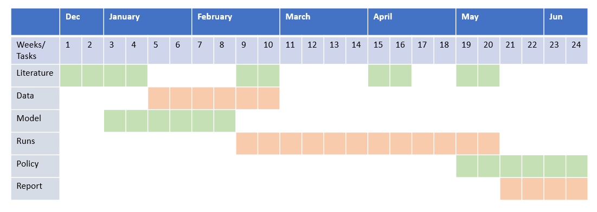
Table 1: Timeline

D References
[1] Energy Act 730.0, Swiss Federal Office of Energy (SFOE)
https://www.admin.ch/opc/fr/classified-compilation/20121295/index.html
[2] Mohammed Muaafa, Iqbal Adjali, Patrick Bean, Rolando Fuentes, Steven O. Kimbrough,
Frederic H. Murphy, Can adoption of rooftop solar panels trigger a utility death spiral? A tale of two U.S. cities, Energy Research & Social Science 34 (2017) 154–162

[3] Nicholas D. Laws, Brenden P. Epps, Steven O. Peterson, Mark S. Laser, G. Kamau Wanjiru, On the utility death spiral and the impact of utility rate structures on the adoption of residential solar photovoltaics and energy storage, Applied Energy 185 (2017) 627–641

[4] Kenneth W. Costello and Ross C. Hemphill, Electric Utilities’ ‘Death Spiral’: Hyperbole or Reality? Available: http://dx.doi.org/10.1016/j.tej.2014.09.011

[5] Alejandro Nuñez-Jimenez, Enhancing PV systems adoption by Swiss households, a system dynamics policy analysis, Semester Project at Chair Management of Network Industries under Prof. Matthias Finger, École Polytechnique Fédérale de Lausanne. Available: https://www.researchgate.net/publication/312219351

[6] Stavroula Margelou, Assessment of long term solar PV diffusion in Switzerland: Agent-based diffusion model for single family houses, Master Thesis carried out at Paul Scherrer Institut (PSI) – Villigen, Switzerland under Prof. Matthias Finger (MIR)

[7] Eric Bonabeau, Agent-based modeling: Methods and techniques for simulating human systems, 7280–7287 PNAS, May 14, 2002, vol. 99, suppl. 3. Available: www.pnas.org/cgi/doi/10.1073/pnas.082080899

E Planned Deliverables
Mid-term presentation: March Week 2/3. At the middle of the project, the work will be presented to the supervisors and interested persons for feedback.
Draft report: June Week 1. 1 week prior to the final presentation a pdf of the draft report will be sent to the supervisors.
Final presentation: June Week 2/3. At the end of the project, the work will be presented to the chair during a group meeting or equivalent.
Final report: June Week 2/3. Final report (PDF, hard copy, simulation files, …) is due on/before the end date.

